Description on how to download fundamental data from Way2Wealth:

Way2Wealth website provides up to 5 years of fundamental data in various reports, such as key financial ratios, income statement, balancesheet, cashflow, quarterly to annual results. For example,

https://www.way2wealth.com/company-information/ratio/jsw-steel-ltd
https://www.way2wealth.com/company-information/incomestatement/jsw-steel-ltd
https://www.way2wealth.com/company-information/cashflow/jsw-steel-ltd
https://www.way2wealth.com/company-information/quaterlyresults/jsw-steel-ltd
https://www.way2wealth.com/company-information/halfyearlyresults/jsw-steel-ltd
https://www.way2wealth.com/company-information/annualresults/jsw-steel-ltd

Such fundamental data can be downloaded and saved in a spreadsheet file using MyWebServer feature in HSQuote Plus, with ONLY ONE format file (way2wealth_fundareports_D1.fmt).

Set-up:

- Copy the following line and append to your existing “mywebserver.txt”, or simply substitute it with the given “mywebserver.txt”, if this line is not already there.

report-XXXX,https://www.way2wealth.com/company-information/XXXX/SSSS,D1,way2wealth_fundareports_D1.fmt

- Save the attached “way2wealth_fundareports_D1.fmt” file in the “fmt” subfolder in the Data File location.
- Save the attached “config_S.cfg” file in the program installation location. This file defines 1 column for Symbol only, and will be used instead of the default config.cfg file.
- Run HSQuote Plus and set up the screen as shown. Please note that the portfolio name should be “report-ratio.tic”, “report-incomestatement.tic”, “report-cashflow.tic”, “report-quaterlyresults.tic”, “report-halfyearlyresults.tic”, and “report-annualresults.tic”.

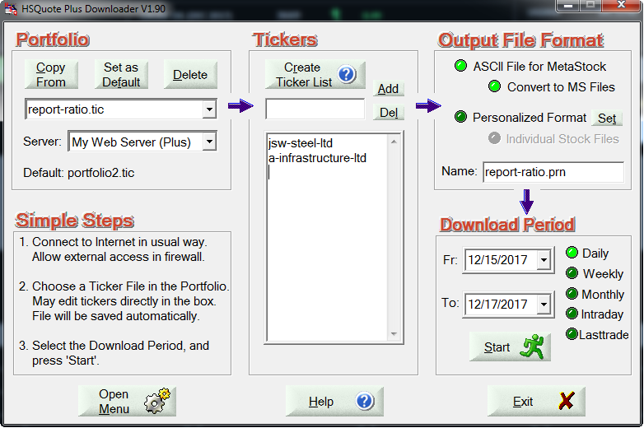

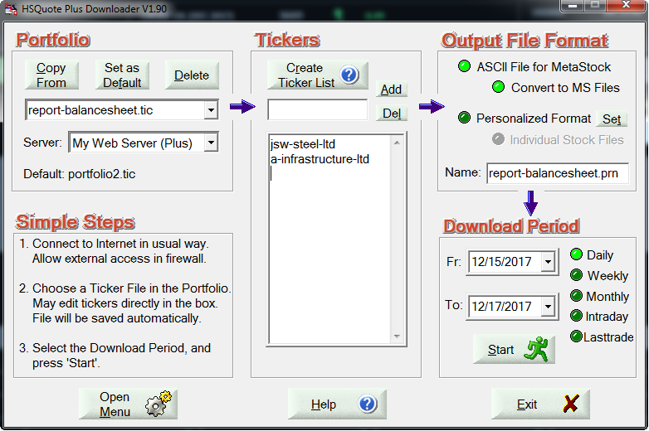

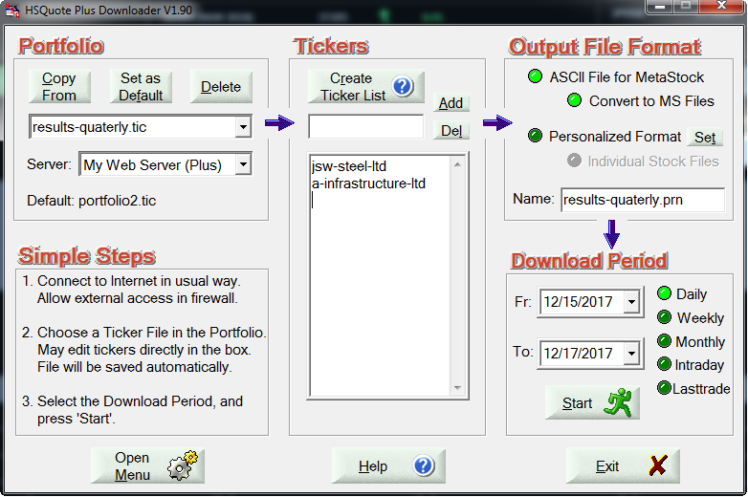

Download:

- On the main screen, select “Personalized Format”. If individual files for each symbol are required, select “Individual Stock Files” as well.
- Select Daily for the Download Period, and press the Start button to download data.
- Fundamental data will be saved in the corresponding .csv file in the named portfolio folder inside the Data File location. Individual files are stored in the “Text-Files” subfolder within this folder.

